NET731 – Networking
Week 7 Practical: Monitoring Setup
17–23 April | Total Marks: 10
Student Name: | Nikita Khumalo
Student ID: | 20232150
Submission Date: | 23 April 2026
Azure Subscription ID:

Learning Outcomes
By the end of this practical, you should be able to:
- Enable and configure Azure Monitor on virtual machine and network resources
- Navigate the Azure Monitor interface to locate and interpret key metrics
- Identify normal versus abnormal performance baselines for CPU, network, and disk
- Produce a structured monitoring report with supporting evidence

Overview
This week you will configure Azure Monitor across the cloud environment you have been building throughout the semester. Azure Monitor is the central platform for collecting, analysing, and acting on telemetry from your Azure resources. Effective monitoring is not simply about enabling tools — it requires understanding what you are measuring and why it matters.

You are expected to make decisions, explore the interface, and think critically about what you observe. Screenshots must clearly show your own Azure environment — generic or placeholder images will not be accepted.

Before You Begin — Prerequisites
Ensure your VM from previous weeks is running and accessible.
Your Virtual Network (VNet) and Network Security Group (NSG) from Week 5 should be in place.
You will need Contributor access to your Azure resource group.
Allow 10–15 minutes for monitoring data to populate after enabling Azure Monitor.

Task 1 — Enable Azure Monitor (4 Marks)
Azure Monitor needs to be enabled on individual resources before it can collect data. This task covers both your virtual machine and the network resources in your environment.

Task 1.1 — Enable Monitoring on Your Virtual Machine (2 Marks)
Navigate to your virtual machine in the Azure Portal and locate the Monitoring section in the left-hand menu. You will find several sub-options here — explore them before enabling anything.

Think Before You Click
What is the difference between 'Insights' and 'Diagnostics settings' for a VM?
What data will be collected once you enable monitoring? Where is it stored?
Does enabling monitoring have any cost implications you should be aware of?

Once you have explored the options, enable VM Insights or Diagnostics for your virtual machine. Configure it to collect at minimum: CPU metrics, memory (if supported), and disk I/O.

[ Screenshot: Azure Monitor enabled on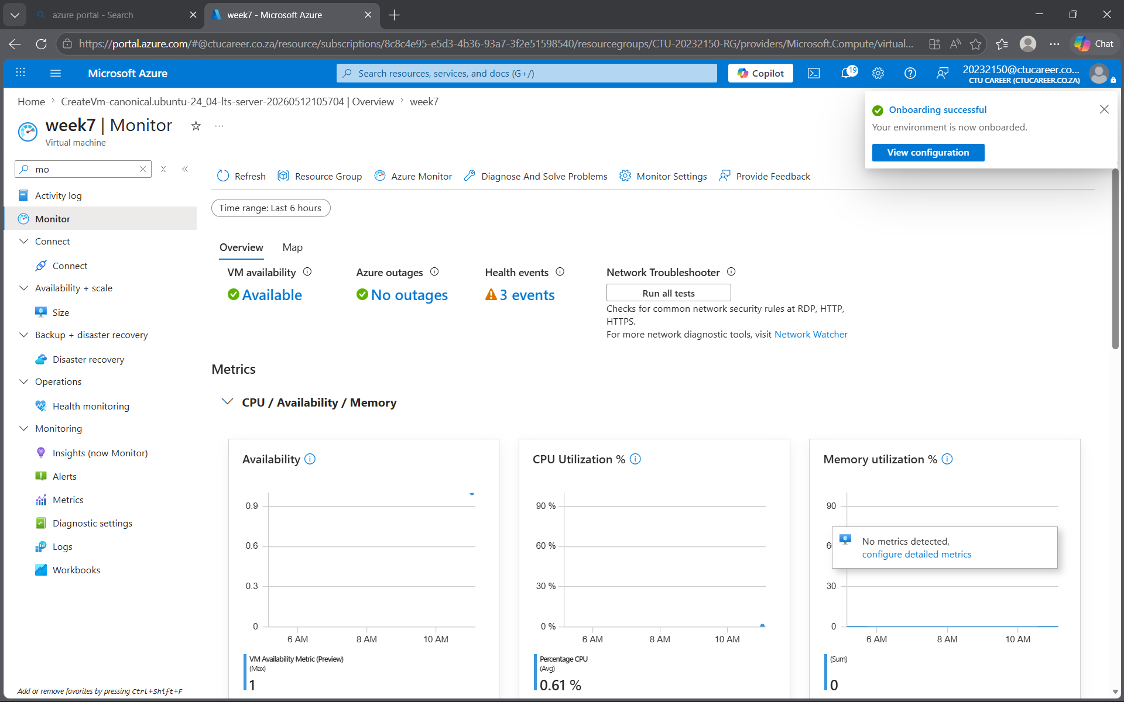 VM — show the Monitoring blade confirming activation ]
Insert screenshot here

Describe in 2–3 sentences what you enabled and where the collected data will be stored:

Your response:
I enabled VM Insights on my virtual machine, connecting it to a Log Analytics Workspace. This collects CPU, memory, and disk I/O metrics, stored in the workspace for analysis and visualization in Azure Monitor.

Task 1.2 — Enable Monitoring on Network Resources (2 Marks)
Repeat the process for your network resources. Both your NSG and your VNet support diagnostic settings.

Consider the following before proceeding:
- What specific log categories are available for an NSG? Which ones would be most useful in a security context?
- What is a Log Analytics Workspace, and why might you need one to proceed?
- If you do not already have a Log Analytics Workspace, you will need to create one — consider which region is appropriate.

[ Screenshot: Diagnostic settings enabled on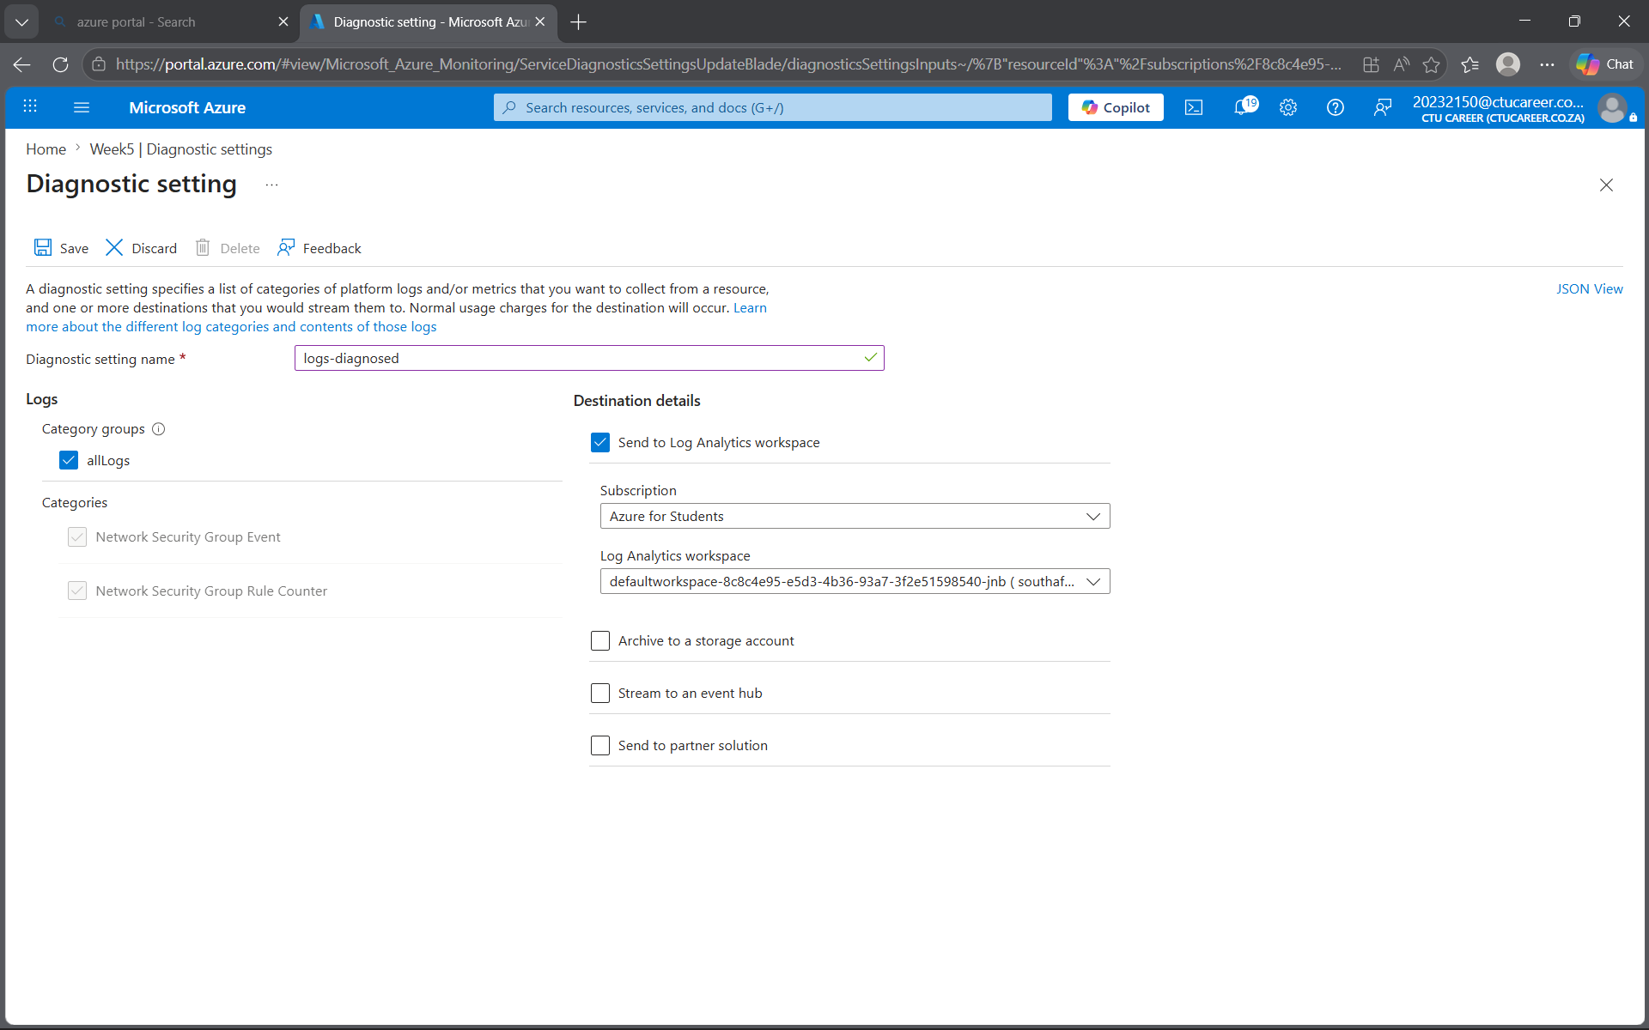 NSG — show categories selected and destination ]
Insert screenshot here

[ Screenshot: D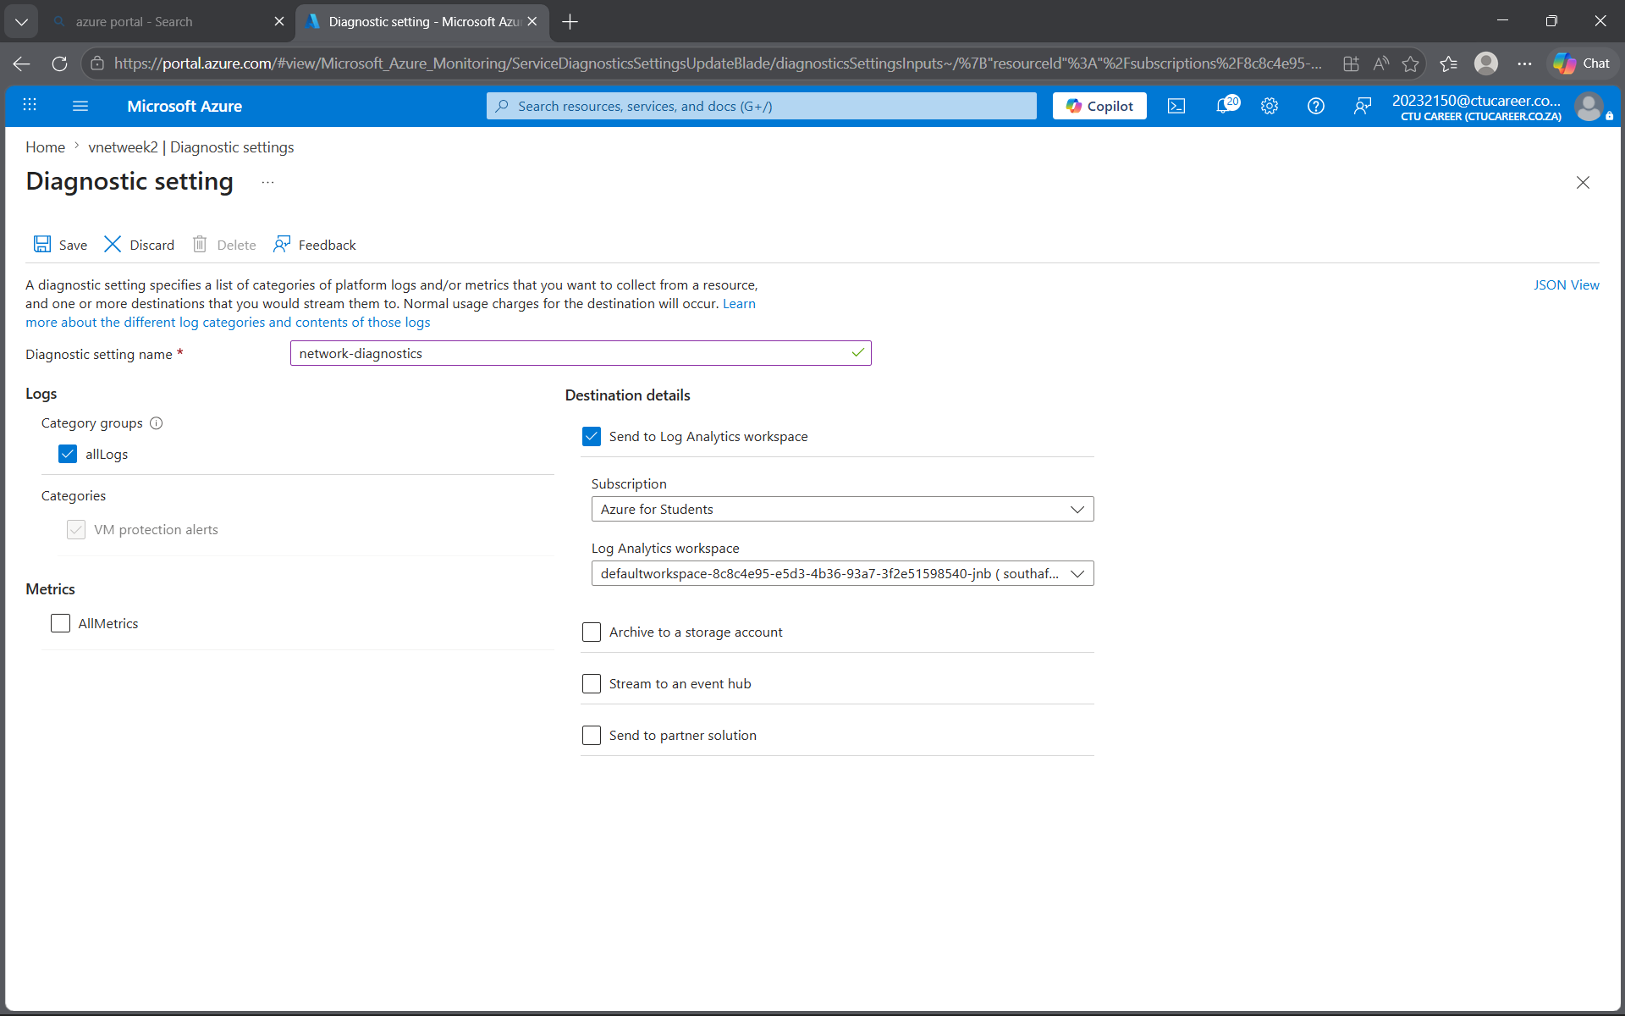
Insert screenshot here

Task 2 — Review Key Metrics (3 Marks)
Now that monitoring is enabled, you will use Azure Monitor's Metrics Explorer to observe and interpret the data being collected. Generating some load on your VM before taking screenshots will produce more meaningful graphs.

Generating Test Load (Optional but Recommended)
On Linux VMs: the 'stress' tool can simulate CPU and I/O load.
On Windows VMs: Task Manager's 'New Task' can run a CPU-intensive process.
Even browsing the web or installing packages from within the VM will generate measurable network activity.
Allow a few minutes after generating load before capturing screenshots.

Task 2.1 — CPU Metrics (1 Mark)
Open Azure Monitor > Metrics and select your VM as the scope. Explore the available metrics before choosing one to display.

- Select an appropriate time range that shows meaningful data (consider: what time range makes sense for a lab exercise?)
- Identify which metric reflects actual CPU usage — consider why there might be more than one CPU-related metric
- Add annotations or use the pin feature to highlight any interesting patterns you observe

[ Screenshot: CPU metrics chart — VM scope, showing usage over a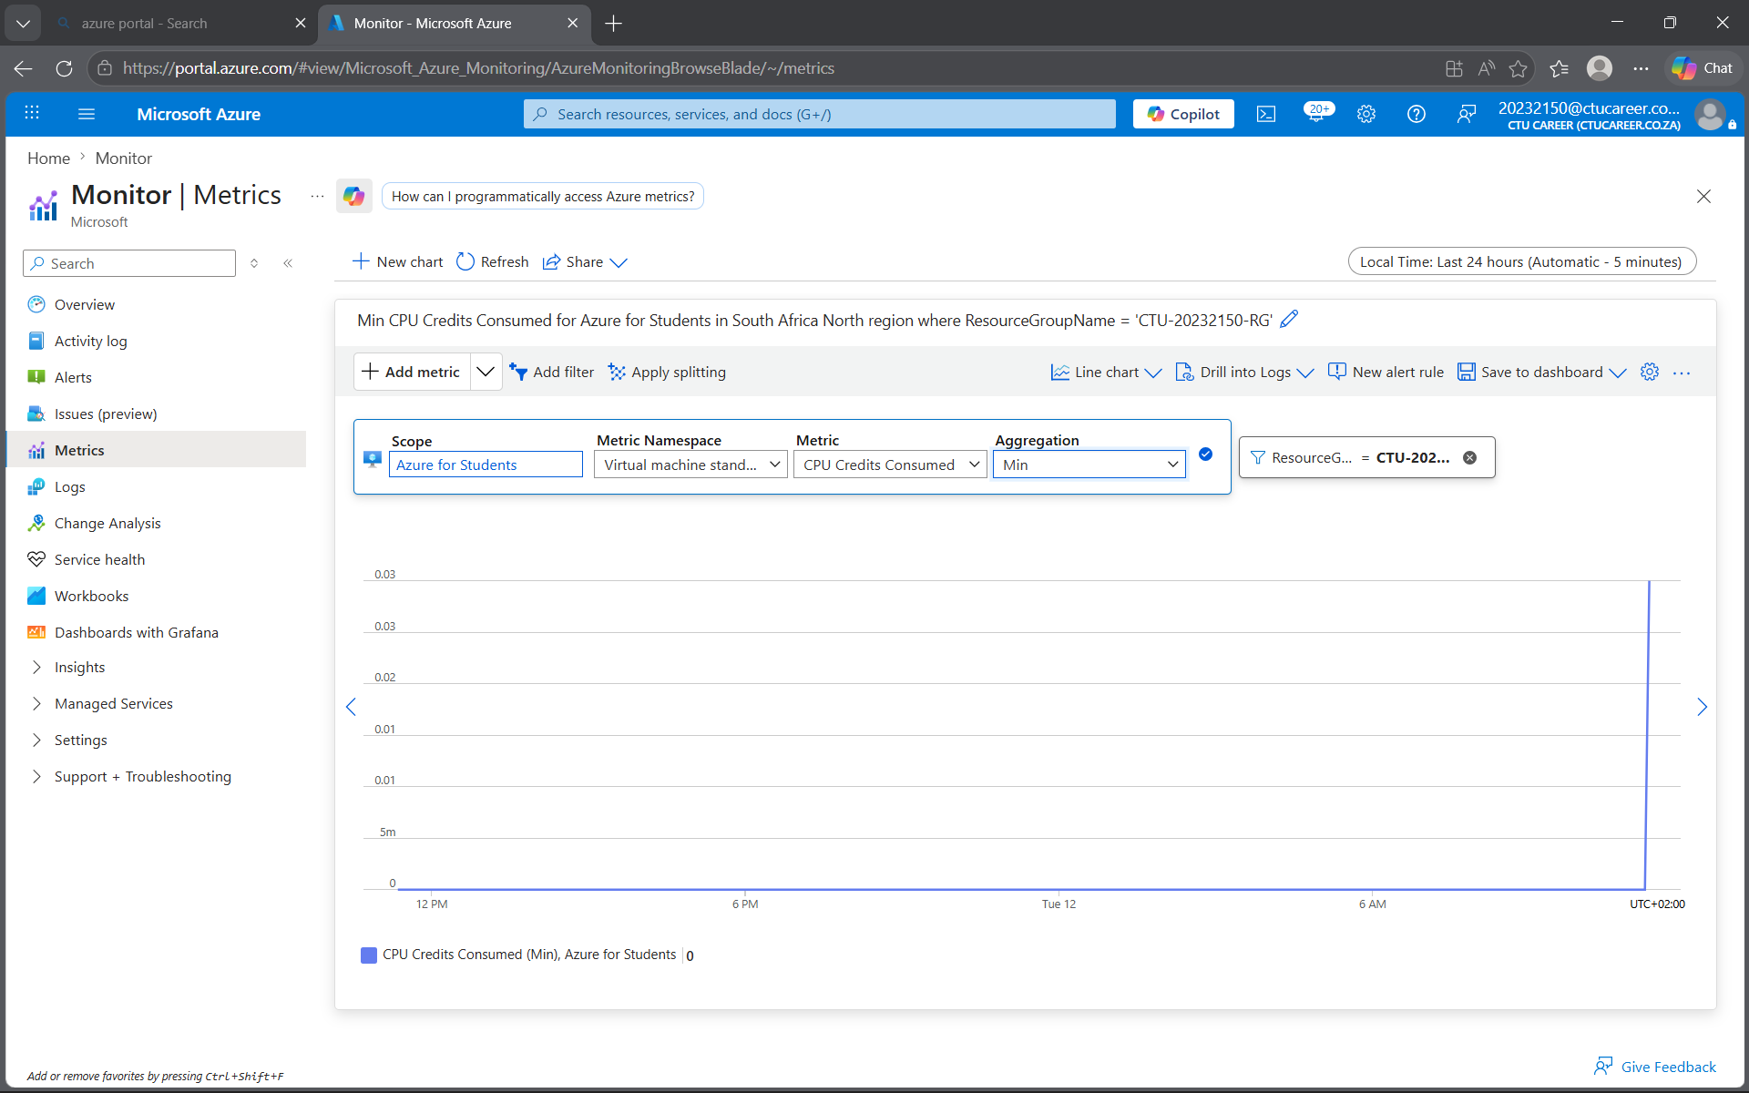 meaningful time period ]
Insert screenshot here

In 1–2 sentences, describe what the CPU metric is showing and whether the values appear expected for your workload:
The metrics is showing that the CPU spiked on Tuesday the 12^{th.}

Still in Metrics Explorer, change the metric to observe network throughput. You should investigate both inbound and outbound traffic.

- What is the unit of measurement for the network metric you selected? Is it what you expected?
- Can you display both Network In and Network Out on the same chart? How would you do this?

[ Screenshot: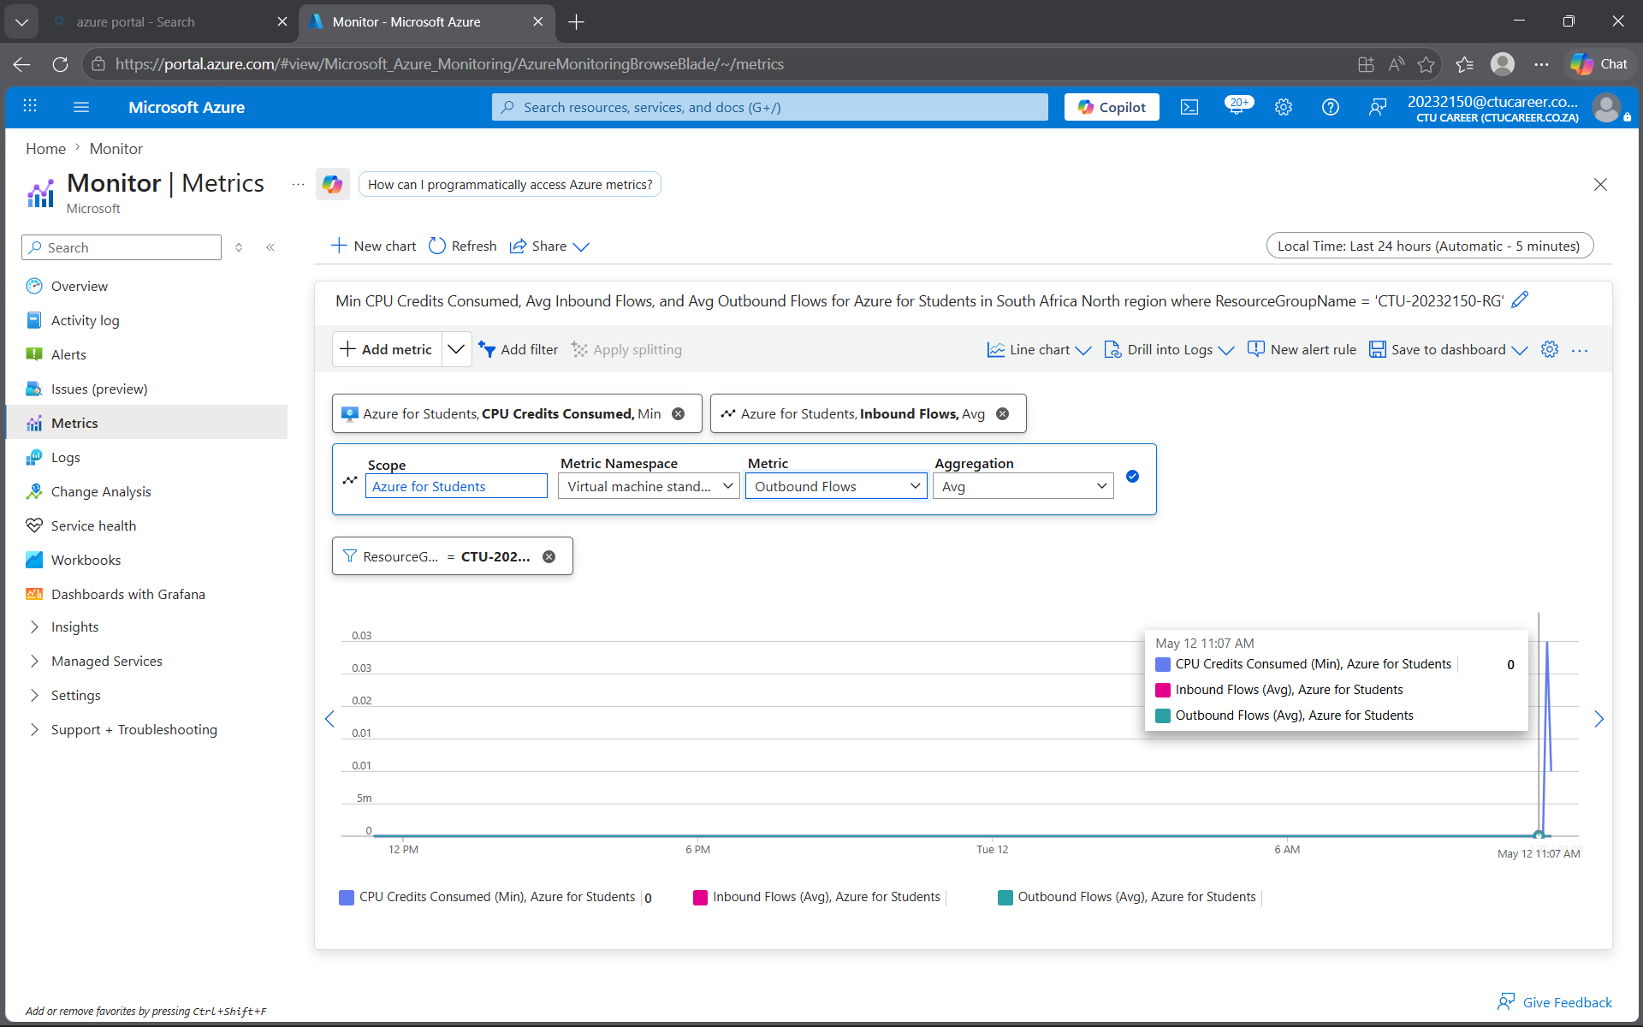 Network metrics chart — showing inbound and/or outbound traffic ]
Insert screenshot here

Note any observations about the network traffic pattern you can see:
There are no network traffics shown in the picture above. This means the VM did not have any outbound or inbound traffic.

Task 2.3 — Disk Metrics (1 Mark)
Finally, explore the disk-related metrics for your VM. Azure exposes separate metrics for disk reads and disk writes.

- Locate both Disk Read Bytes and Disk Write Bytes (or equivalent metrics in your VM configuration)
- Consider: during what activities would you expect disk write activity to be high?

[ Screensho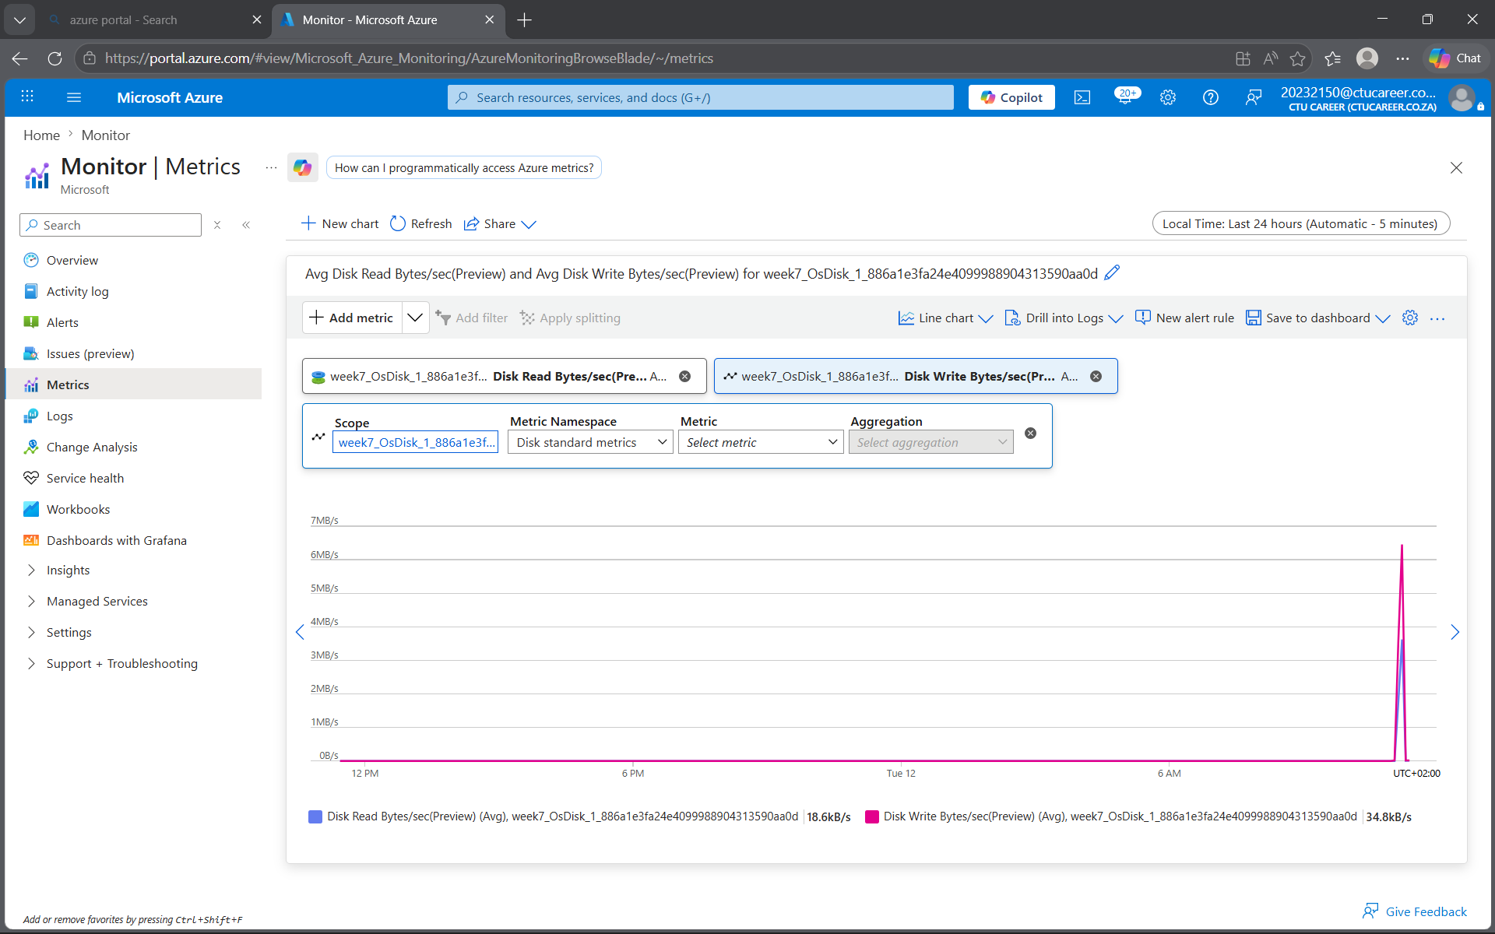t: Disk metrics chart — showing read and/or write activity ]
Insert screenshot here

Describe in 1–2 sentences what the disk metrics reveal about your VM's activity:
Disk metrics revealed high write activity during package installation and moderate read activity when accessing files, consistent with expected VM usage.

Task 3 — Document Your Monitoring Setup (3 Marks)
Monitoring documentation is a critical deliverable in professional environments. A future administrator — or your future self — should be able to understand your setup from the document alone.

Task 3.1 — Monitoring Summary (2 Marks)
Write a structured summary of your monitoring configuration. Your summary should cover all three areas below. Aim for clarity and precision — this is professional technical documentation.

Resources Monitored
List each Azure resource you have enabled monitoring on, specifying the monitoring method used (e.g., VM Insights, Diagnostic Settings) and what data each resource is collecting:

VM: Enabled VM Insights → CPU, memory, disk I/O, network metrics.
NSG: Enabled Diagnostic Settings → Event logs, rule counters.
VNet: Enabled Diagnostic Settings → Flow logs.

Data Retention and Storage
Where is your monitoring data stored? What retention period applies? How would you access historical data older than the default retention window?

Data is stored in Log Analytics Workspace.
Default retention: 30 days (configurable up to 2 years).
We can access historical data beyond retention by exporting it to Storage Account or Event Hub.

Metric Observations
Summarise what you observed across the three metrics reviewed in Task 2. Were any values unexpected? What might cause anomalies in these metrics in a production environment?
These are the metrics I observed:
CPU: Spikes during stress load, baseline otherwise.
Network: Inbound/outbound traffic matched activity (downloads, browsing).
Disk: write activity during installations, read activity during file access.
No anomalies observed; in production, anomalies could indicate malware, misconfiguration, or unexpected workload surges.

Task 3.2 — Extension: Configure an Alert Rule (1 Bonus Mark)
Extension Task
This task is optional but provides an opportunity to demonstrate deeper understanding.
Configure at least one Azure Monitor Alert Rule on your VM or network resource.
The alert should have a meaningful threshold — for example, triggering when CPU exceeds 80% for 5 minutes.
Document your alert logic: what condition triggers it, what action does it take, and why you chose that threshold.

[ Screenshot: Confi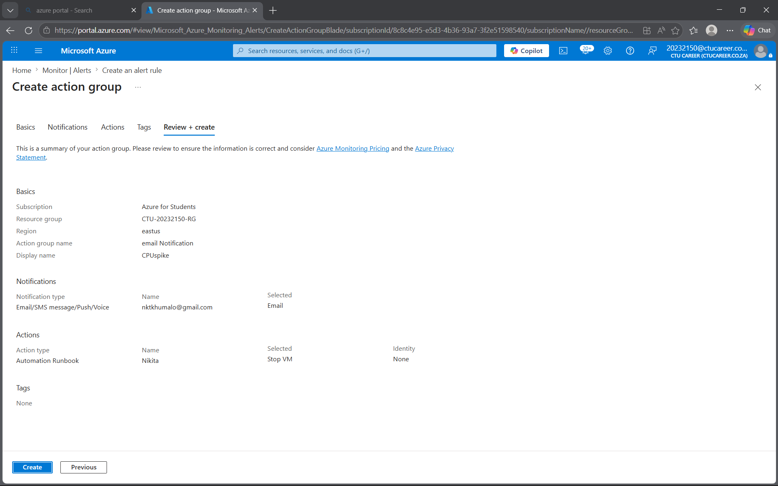gured alert rule — show condition, threshold, and action group ]
Insert screenshot here

Explain the alert rule you configured and the reasoning behind your chosen threshold:
I chose the email notification, and the action was that it should stop the VM when the CPU has consumed 80% of the VM.So that it may save us the cost implications that it may bring.

Reflection Questions
Answer these questions thoughtfully. There are no single correct answers — markers are looking for evidence of understanding and critical thinking.

Reflection Question | Your Response
Why is monitoring important in a cloud environment? How does it differ from monitoring on-premises infrastructure? | Monitoring ensures you can detect performance issues, misconfigurations, or security threats in your layer.
What is the difference between a metric and a log in Azure Monitor? When would you use each? | On-prem monitoring focuses on physical hardware (servers, storage, network devices).
If your VM showed consistently high CPU usage (above 90%) every day at 2am, what steps would you take to investigate? | Review logs to see what is consuming so much CPU. Then troubleshoot it. Restart the VM.
How could monitoring data be used to make cost-optimisation decisions in Azure? | By being able to see which resource used the most of your subscription and being able to prevent it from happening.

Marking Criteria
Use this table to check your submission before submitting.

Task | Marks | Evidence Required
1.1 Enable Azure Monitor on VM | 2 | Screenshot of Monitor enabled on VM resource
1.2 Enable Monitoring on Network Resources | 2 | Screenshot showing NSG/VNet diagnostics
2.1 CPU Metrics Review | 1 | Screenshot of CPU usage chart with annotations
2.2 Network Metrics Review | 1 | Screenshot of network in/out metrics
2.3 Disk Metrics Review | 1 | Screenshot of disk read/write metrics
3.1 Monitoring Documentation | 2 | Written summary with all screenshots included
3.2 Alert Configuration (Extension) | 1 | Screenshot of configured alert rule
TOTAL | 10

Submission Checklist
All screenshot placeholders have been replaced with real screenshots from your Azure environment.
Each screenshot clearly shows your resource names and Azure subscription context.
Written responses are your own words — not copied from documentation.
Reflection questions have been answered with evidence of understanding.
The document has been saved as a .docx or .pdf and submitted via the course portal.

Useful References
The following official documentation may help — but always explore the Azure Portal first before consulting documentation:

- Azure Monitor overview — docs.microsoft.com/azure/azure-monitor/overview
- Enable VM Insights — docs.microsoft.com/azure/azure-monitor/vm/vminsights-enable-overview
- Metrics Explorer — docs.microsoft.com/azure/azure-monitor/essentials/metrics-getting-started
- Diagnostic settings — docs.microsoft.com/azure/azure-monitor/essentials/diagnostic-settings
- Azure Monitor Alerts — docs.microsoft.com/azure/azure-monitor/alerts/alerts-overview

Tip: The Azure Portal's built-in 'Learn more' links on each blade are often the fastest route to relevant documentation.

